Github URL:

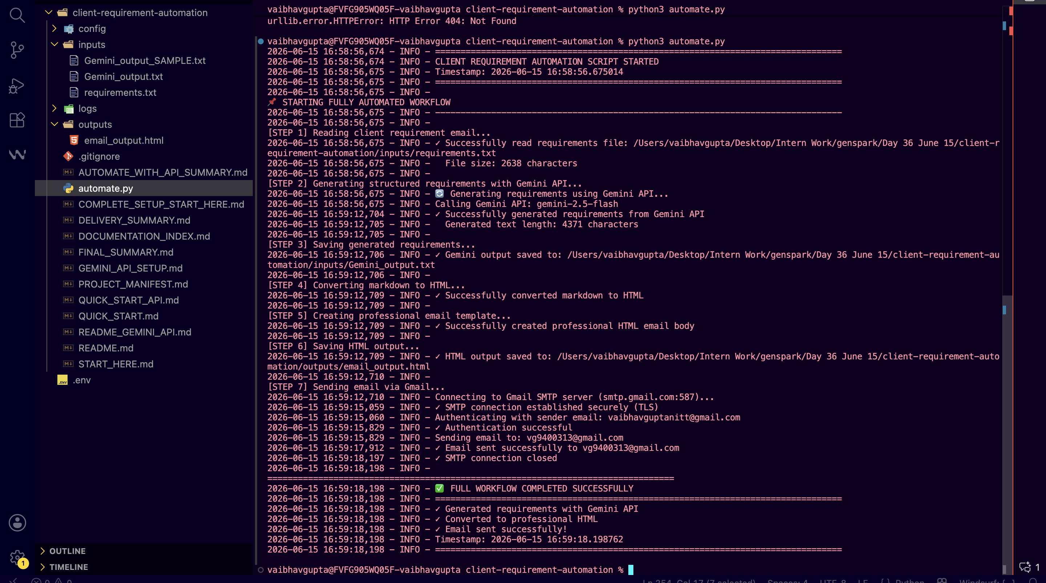

Prompt:
You are an expert Backend Automation Engineer and Python Developer. I am building a project from scratch that automates client requirement processing.

I am using the free version of Gemini API for text generation. Therefore, I need you to write a Python script that orchestrates this workflow seamlessly by reading/upload local files.

Please generate the complete project setup from scratch, including:

1. File Architecture: A clean layout of files and folders.

2. Sample Input File: 'requirements.txt' containing a realistic, unorganized client requirement email.

3. Detailed LLM System Prompt: A prompt I can copy-paste alongside the requirements text into Claude's web UI to generate Functional Requirements, Non-Functional Requirements, Risks, Assumptions, and Questions.

4. Python Automation Script ('automate.py'): A script that:

* Reads the raw client text file ('requirements.txt') for historical logging/reference.

* Reads the markdown text response from Gemini ('Gemini_output.txt').

* Coverts that raw markdown text into an elegant, HTML-formatted corporate email body (using inline CSS for a professional look with navy headers).

* Uses Python's native 'smtplib' and 'email' modules to securely log into Gmail using an App Password and send the formatted email to a target email account.

5. Setup & Execution Guide: Step-by-step instructions on how to set up the Python environment, generate a Google App Password, and run the script.

Provide complete, robust Python code with error handling (try-except blocks) and detailed comments. Do not use complex external markdown-to-html libraries; handle the text formatting cleanly with native Python string replacements so it runs without heavy dependencies.
Here is actual Problem Statement:

Scenario:
A client sends a requirement email.
Automation:
Read requirement text file.
Claude generates:
Functional Requirements
Non-functional Requirements
Risks
Assumptions
Questions to Client
Create formatted email.
Send to a Gmail account.

Sample Requirement
Subject: Website Redesign Project - Requirements & Timeline

Hi there,

Hope you're having a great week! I need to get this website project rolling ASAP. Our current site is pretty outdated and we're losing customers to competitors who have better online experiences.

Here's what we need:

1. The homepage should be modern and eye-catching - use latest design trends. We want it to load super fast, ideally under 2 seconds on 4G. Mobile needs to be perfect too since most of our traffic comes from phones.

2. We need a product catalog with filtering - customers should be able to filter by price, category, color, size. Search function is critical here because our current search is broken and frustrates users.

3. Shopping cart functionality - duh! But also the ability to save items for later. We're seeing people abandon carts and I think it's because they can't save things.

4. User accounts - customers should be able to create accounts and see their order history. Maybe newsletter signup too? We want to build our email list.

5. Payment integration - we use Stripe currently. Need to handle multiple currencies eventually but US & Canada first. Also need Apple Pay and Google Pay options because people are lazy and don't want to type card details.

6. Admin dashboard - we need to manage inventory, see orders, generate reports. Export data to Excel please. Real-time analytics would be nice but only if it doesn't slow things down.

7. SEO optimization - it needs to rank for keywords like "luxury home furniture" and "modern dining chairs". Current site is invisible on Google.

8. Security - PCI compliance obviously since we take payments. GDPR too since some European customers visit the site. We've had some sketchy traffic lately so maybe DDoS protection?

9. The site should integrate with our warehouse system somehow? I'm not sure exactly how yet but we need inventory to be updated automatically. Our current process involves someone manually updating numbers which is a nightmare.

10. One more thing - users have been asking for a wishlist feature, live chat support, and the ability to gift products to friends. These would be nice to have but not day-one requirements.

Budget is around $50k and we'd like this live in 3 months. We're a small team so documentation and training on how to maintain the site will be important.

Our business is doing ~$2M in annual revenue and we expect this redesign to boost conversion by at least 20%. Traffic is about 50k unique visitors per month.

Let me know if you have questions or need clarification. I'll loop in our tech lead Sarah next week if needed.

Cheers,
John

Gemini Output
# FUNCTIONAL REQUIREMENTS
## Must Have (MVP)
* Modern, eye-catching homepage design following latest trends.
* Mobile-first responsive design across all pages.
* Product catalog with filtering by price, category, color, and size.
* Functional and robust product search capability.
* Shopping cart functionality.
* User accounts with customer registration and order history viewing.
* Stripe payment integration supporting US and Canadian currencies.
* Apple Pay and Google Pay integration.
* Admin dashboard for inventory management, order viewing, and basic reports.
* Data export functionality (e.g., to Excel) from the Admin Dashboard.
* SEO optimization for keywords like "luxury home furniture" and "modern dining chairs".
* Integration with existing warehouse system for automatic inventory updates.
* Documentation and training for site maintenance.
* Basic lead capture for email list building (e.g., newsletter signup).

## Should Have
* Save for later functionality within the shopping cart.
* Capability for future expansion to handle multiple currencies beyond US and Canada.
* Real-time analytics in the Admin Dashboard (conditional on not impacting performance).

## Could Have
* Wishlist feature for users.
* Live chat support integration.
* Ability to gift products to friends.

# NON-FUNCTIONAL REQUIREMENTS
## Performance
* Homepage load time under 2 seconds on 4G.
* Optimal performance and user experience on mobile devices.
* Overall fast site loading and responsiveness.

## Security
* PCI DSS compliance for payment processing.
* GDPR compliance for European customers.
* DDoS protection.
* Secure handling of user data and accounts.

## Scalability
* Support for current traffic (50k unique visitors/month) and anticipated growth (20% conversion boost).
* Architectural flexibility to accommodate future feature expansion (e.g., multi-currency).

# TECHNICAL CONSTRAINTS & ASSUMPTIONS
* **Budget:** Approximately $50,000.
* **Timeline:** 3 months for initial launch.
* **Payment Gateway:** Must integrate with existing Stripe account.
* **Existing System Integration:** Requires integration with an unspecified warehouse system for inventory.
* **Assumption:** Client will provide necessary access, documentation, and technical points of contact (e.g., Tech Lead Sarah) for warehouse system integration.
* **Assumption:** The 3-month timeline and $50k budget are for the "Must Have" MVP features, with "Should Have" and "Could Have" features considered for subsequent phases.

# IDENTIFIED RISKS
* **Scope Creep:** Pressure to include "Should Have" or "Could Have" features in the MVP could jeopardize budget and timeline.
* **Undefined Warehouse Integration:** Lack of detailed specifications for the existing warehouse system could lead to significant delays, increased costs, or integration challenges.
* **Budget/Timeline Mismatch:** The specified budget and timeline may be insufficient for all "Must Have" features, especially considering complex integrations and compliance requirements.
* **Performance vs. Feature Trade-offs:** Implementing certain "Should Have" features (e.g., real-time analytics) might conflict with the strict performance requirements.
* **Security Compliance Complexity:** Ensuring full PCI and GDPR compliance within the given budget and timeline can be complex and require significant effort.

# QUESTIONS FOR CLIENT
* Can you provide documentation or detailed specifications for your existing warehouse system, including its API or data exchange capabilities?
* What specific data points or functionalities are essential for the basic reports in the Admin Dashboard?
* Do you have any existing brand guidelines, design preferences, or competitor sites you admire for the "modern and eye-catching" homepage?
* What are the key metrics or KPIs you will use to measure the projected 20% conversion boost?
* For the "save for later" functionality, should items be saved indefinitely, and is it tied to user accounts or also available for guest users?
* What is the expected volume and frequency of data exports to Excel, and are there specific data sets required?
* When would your tech lead, Sarah, be available for an initial technical discussion regarding the warehouse integration and other system architecture details?

Received Mail Screenshot”:
